Unified Ensemble Learning for Cyber Attack Detection and Classification in Wireless Sensor Networks

Chitralingappa P
Computer Science and Engineering(Data Science)
Srinivasa Ramanujan Institute of Technology
Anantapur,India
p.chitraligappa@gmail.com
Karthik P
Computer Science and Engineering(Data Science)
Srinivasa Ramanujan Institute of Technology
Anantapur,India
penukondakarthik5@gmail.com
Lakshmi Moksha B
Computer Science and Engineering(Data Science)
Srinivasa Ramanujan Institute of Technology
Anantapur,India
lakshmimoksha.132@gmail.com
Akash R
Computer Science and Engineering(Data Science)
Srinivasa Ramanujan Institute of Technology
Anantapur,India
akashramugalla@gmail.com
Dinesh Reddy C
Computer Science and Engineering(Data Science)
Srinivasa Ramanujan Institute of Technology
Anantapur,India
dineshreddy3450@gmail.com

Abstract— Wireless Sensor Networks (WSNs) are now widely adopted across many domains such as industry, environmental monitoring, and healthcare. A cyberattack is an unauthorized attempt to access, disrupt, manipulate, or destroy information systems, networks, or data resources. However, WSNs are highly susceptible to cyberattacks due to their wireless communication nature, limited computing power, and energy consumption. Current cyberattack detection systems are mainly concerned with detecting the occurrence of an attack, whereas the precise classification of multiple attacks has been a significant impediment in dynamic environments of WSN systems. Our proposed ensemble-based system detects and classifies cyberattacks in WSNs by integrating several models, such as XGBoost, Multilayer Perceptron (MLP), and Autoencoder, into the unified stacking ensemble model to enhance the detection accuracy, classification stability, and responsiveness to changing attack patterns. The WSN-DS was used to train this model and realistic network traffic was simulated in the COOJA environment to test the model. The contributions are mainly the improved multi-attack classification accuracy, the improved detection under various network conditions and development of a scalable and viable cybersecurity system applicable in actual-time Wireless Sensor Network conditions.
Keywords— Cyber Security, Wireless Sensor Networks, Ensemble Techniques, Cyber Attacks, COOJA.

Introduction
The application of Wireless Sensor Networks is common in industrial automation, environmental monitoring, as well as in healthcare. Combined with the Internet of Things (IoT), they enable a steady collection of data and assist in informative and timely real-time decision making [20]. Attacks are a threat to WSNs due to their open wireless medium and limited hardware resources. As an illustration, attackers can use weak processing power and battery life [1][6][12].
A cyberattack refers to the illegal attempt to gain access to, degrade, or disrupt computer systems, computer networks, or computer-related data. Blackhole, Grayhole, Flooding and TDMA-based attacks are some of the cyberattacks that have become a significant security threat, as WSNs are deployed swiftly. A Blackhole attack is an attack where a malicious node will claim to have the best path to the base station and proceeds to discard every packet it gets [21]. Grayhole attack is more misleading since it is only the selected packets that are dropped and this makes it more challenging to detect. Flooding attacks introduce too many packets into the network hence jamming it and consuming a lot of energy of sensor nodes in no time. During TDMA-based attacks, an attacker sends his data at unauthorized time slots thereby causing collisions and interfering with regular communication. These attacks sabotage routing processes, more packets are lost, and more power is used in sensor nodes [8][10]. Most security systems available today are primarily geared towards the detection of attacks and they usually do not effectively categorize various types of attacks or are not modified to match the changing threat of a dynamic network environment [2]. Also, benchmark data sets like WSN-DS have assisted researchers to examine WSN communication behavior and attack patterns in a better manner [16].
To deal with these issues, smart and responsive cybersecurity technologies are necessary. Machine learning and deep learning in combination with ensemble learning models can enhance the detection accuracy and stability of classification and the robustness of the system. This method enables the system to deal with the complex and changing network conditions in a better way. Therefore, the suggested system uses various ensemble learning models as a single ensemble model to enhance the detection and classification of cyberattacks [24]. This system can produce the outputs of many models and thus identify even previously unnoticed attacks, enhancing the performance of the system in real life, and it is designed to work in resource-limited systems like WSNs.

RELATED WORK
Wireless Sensor Networks (WSNs) have a high susceptibility to cyberattacks since they are spread out, use wireless communication media and lack the necessary resources in terms of computation and power. The use of cryptographic protection is often inadequate for WSN environments as attackers can compromise the sensor nodes, introduce malicious packets, or perform denial-of-service attacks to disrupt network services [11]. Besides, it is not easy to employ elaborate security systems on every sensor node due to hardware and battery capacity constraints, and therefore, effective and compact cyberattack detection methods are critical in WSN security [7][13].
In order to mitigate these threats, machine learning-based and anomaly detection methods have been extensively investigated [4]. Network traffic patterns are analyzed using models such as XGBoost, Random Forest, and ensemble based algorithms to detect abnormal behavior and known attack signatures. These models often provide excellent detection and classification performance. Nevertheless, many machine learning methods have limitations in adapting to new or evolving attack patterns and often show performance variations depending on attack type. Moreover, they may not perform consistently in dynamic real-time WSN environments [3][5][9][15].
Deep learning methods have also enhanced cyberattack detection by learning complex and nonlinear relationships in network traffic data [23]. Multilayer Perceptron and Autoencoder models have shown good results in detecting cyberattacks and classifying network behavior. Those models however tend to be large trained model and heavy computation resources which are not easily available in resource constrained WSN environments [14][18][22].
Specialized datasets have also helped in developing intelligent cyber security models. The WSN-DS dataset was actually developed to model the real-world WSN communication behavior and different denial-of-service attack scenarios. Models that are learned with this dataset are more likely to differentiate between normal and malicious network. act and enhance the detection and classification performance [17].
Though there has been a great advancement in the research of cyberattack detection in Wireless Sensor Networks, a number of challenges still exist. Numerous current methods cannot detect the changing patterns of attacks and they are also incapable of categorizing the precise type of attack and they are also expensive to train the deep learning models [19]. Moreover, the available systems are mostly based on single-model learning methods and do not have adaptive multi-model systems that can be used in the context of real-time WSN. These restrictions demonstrate the necessity of intelligent security frameworks that are hybridized ensemble-based and have the capacity. of offering precise, scalable, as well as versatile cyberattack detection and categorization in dynamic Wireless Sensor Network environments.

PROPOSED METHODOLOGY
A. System Overview
To overcome the limitations of traditional cyberattack detection approaches in Wireless Sensor Networks (WSNs), this study presents a hybrid ensemble-based cyberattack detection and prevention framework. The developed model accurately identifies and categorizes various types of cyberattacks and detects new or unfamiliar attack patterns. The system enhances the detection accuracy, classification reliability and scalability to dynamic network conditions by combining several models into one Unified Ensemble model. The system supports multi-attack classification, detection of anomalies, and stores them in forensics logs.
B. Design Architecture
The design of our proposed system is shown in Fig. 1. The system contains three main modules: the user interaction module (UI), cyberattack detection engine, and data storage module. The user interface module is used to provide interaction between the user and the system where several features such as the uploading of the dataset, registration of the user, authentication, and access to forensic logs, prevention reports and detection outputs may be provided.
The cyberattack detection engine is the key processing component of the system. It will do the preprocessing of the data, run ensemble learning models, detect possible cyberattacks, categorize the type of attack, and recommendations on what measures should be taken to prevent the attack. The engine flexibly analyzes the network behavior to identify suspicious patterns of network behavior. It enhances detection reliability by integrating more learning methods.
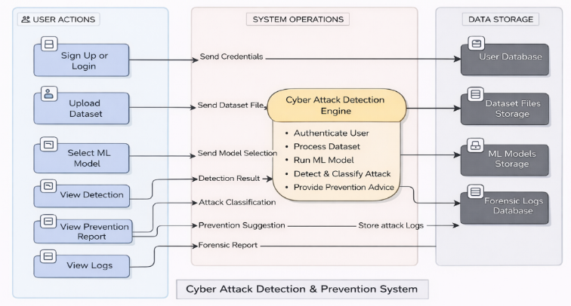

Fig. 1. Proposed Cyber Attack Detection and Prevention Design Architecture
All of the significant system information is stored in the data storage module in detailed forensic attack logs. This enables network activity to be easily monitored by the administrators and security audits to be carried out. The logs may be sorted by date, month, or year, wherein it is convenient to research a particular incident and compare attack patterns with time. This structured storage and filtering service allows responding to threats faster and helps to conduct a long-term security control within the Wireless Sensor Network.
C. Dataset Processing Workflow
Data Processing framework is shown in Fig.2. The workflow starts with data training by utilizing the WSN DS benchmark dataset to collect information and network traffic information through the COOJA simulation environment, which would be used to test and validate the experiment and make sure that realistic scenarios regarding the communication of the Wireless Sensor Network and cyberattacks would be provided.
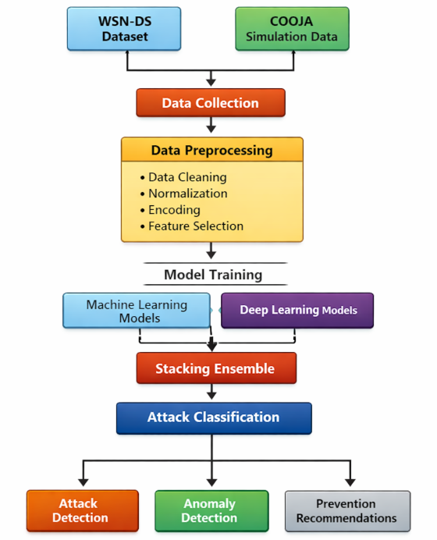
Fig. 2. Data Flow Diagram
Data cleaning, data normalization, categorical encoding, and feature selection are carried out to perform preprocessing of the collected data to improve data quality and model training. Then unified ensemble model is trained using processed dataset. This system uses several ensemble models to detect complex network traffic patterns. Stacking ensemble learning integrates the model outputs to get attack classification output. It is used to perform multi-attack classification, to detect seen or unseen cyberattacks. The system also writes prevention recommendations based on the outcome of the detection to aid proactive cybersecurity monitoring in Wireless Sensor Network networks.


D. Ensemble Learning
The proposed system makes use of the unified ensemble learning model to improve the dependability of cyberattack classification and the accuracy of cyberattack detection in WSNs. Rather than depending just on a single learning model, the system integrates hybrid learning models to learn different patterns of network traffic behavior and cyberattack patterns.
One of the base models is Random Forest because of the high classification ability and resistance to the noisy and high-dimensional data. There is a significant variability and noise present in the wireless sensor network traffic data because of the interference in communication and environmental factors. Random Forest can be used to address such variations and can be used to give consistent baseline classification performance.
The XGBoost is also present in the framework to enhance the accuracy of prediction by means of boosting based learning. It is suitable in dealing with non-linear boundaries of decisions and fine changes between an ordinary and an attack traffic. This makes it appropriate to the identification of advanced cases of cyberattacks, which cannot be readily distinguished by conventional machine learning frameworks.
Multilayer Perceptron (MLP) model is utilized to extract the nonlinear relations among network traffic data. The patterns of WSN communication are in most cases nonlinear and conceal dependencies among the network parameters which include the rate of packet transmission, delay, and the energy consumed. The MLP model assists in learning such nonlinear patterns, and enhances the overall capability of attack classification.
The Autoencoder model is applied in detecting anomalies and identifying the previously unseen or unknown cyberattack patterns. In contrast to supervised models, the Autoencoder searches the regular behavior of the network and discovers anomalies in the pattern of expected communications. This allows the system to identify the unknown attacks which are not available in the training dataset.
This model performs anomaly detection independently and does not rely on the stacking ensemble classification process. The output of individual models is combined to form stacking ensemble learning so that performance of the entire system is enhanced. In stacking ensemble learning, the results of base models are stacked and utilized as input to the last classification layer. This method enhances the stability of the detector and assists in lowering false positive and false negative errors as opposed to predictions using individual models.
E. Attack Detection and Anomaly Detection Mechanism
The proposed system finds previously undiscovered attack patterns and recognizes and classifies different kinds of cyberattacks in wireless sensor networks. The system combines several models to detect known attacks and deep learning-based anomaly detection to identify unknown threats.
Random Forest and XGBoost are used to identify the Blackhole attack. In a Blackhole attack, a compromised sensor node falsely advertises optimal routing information to attract surrounding traffic. Once neighboring nodes forward their packets through this malicious node, it intentionally drops the received data instead of relaying it, resulting in severe packet loss and disruption of routing integrity within the network. This leads to the abnormal routing patterns and abrupt loss of packets. Random Forest can be used to achieve consistent classification with routing-based attack patterns, and XGBoost can be used to detect subtle variations between a normal and malicious routing behavior.
XGBoost and Multilayer Perceptron (MLP) models are used to identify the Grayhole attack. In contrast to the Blackhole attacks, the Grayhole attacks are selective in that they drop the packets selectively thus becoming hard to identify by simple pattern recognition. XGBoost is used in identifying partial traffic abnormalities whereas the MLP model is used to identify non-linear variations in traffic behaviour correlated with the selective loss of packets.
Random Forest and XGBoost models are used to detect flooding attacks. Flooding attacks cause high traffic in the network and consequently, the transmission rate of packets and network congestion. Such attacks result in tremendous deviation in the amount of traffic and frequency of communication, which may be successfully identified with statistical classification and boosting-based classification models.
Multilayer Perceptron model is mainly used in detecting TDMA based attacks. These attacks interfere with the time-slot based communication scheduling where data are sent beyond the scheduled time slots. MLP model is useful in identifying abnormal timing and communication pattern deviation in a model that is hard to capture.
Besides the familiar classification of attacks, the proposed system also includes anomaly detection with the help of an Autoencoder model. The Autoencoder is trained on typical network communication behavior and it identifies aberrant behavior. In case the incoming network traffic does not match any of the trained attack classes or normal traffic patterns, the traffic is labeled as an unknown anomaly attack. This allows the detection of unknown or unseen attacks, and emerging cyber threats that are absent in the training data.
The proposed system offers an integrated method of cyberattack detection that is suitable for dynamically fluctuating Wireless Sensor Networks by incorporating supervised learning to identify known attacks and unsupervised learning to identify unknown threats in the network.

EVALUATION SETUP
The purpose of the experiment is to evaluate how well the suggested unified ensemble-based cyberattack detection system for Wireless Sensor Networks (WSNs) performs. Benchmark datasets and network traffic simulations are used to create realistic test conditions. The available dataset is partitioned so that most samples (80%) are used for model training, while (20%) is used to test model performance. The simulation generated dataset and the WSN-DS dataset are preprocessed and handled independently to prevent data leakage.
A. Training Dataset
The proposed cyberattack detection framework is trained using the wireless sensor networks dataset (WSN DS), a benchmark dataset used for cyberattack analysis in Wireless Sensor Networks. WSN-DS dataset contains both the legitimate communication records and various types of malicious network behavior. Such attack scenarios comprise routing manipulation attack, selective forwarding attacks, traffic flooding cases and time slot scheduling attacks. The data set includes communication rates, including packet transmission rates, routing routes and node energy expenditure which allow assessment of intrusion detection models in the Wireless Sensor Networks comprehensively.
The dataset captures important network communication properties like routing behaviour, patterns of packet transmission, association of cluster heads, distance of communication and power usage by the nodes. The parameters assist in discerning the abnormal node behavior and cyberattacks.
This unified ensemble model incorporates the use of Random Forest, XGBoost, Multilayer Perceptron, and Autoencoder in one framework, which aids in enhancing the detection accuracy, stability in the classification, and detecting anomalies in the context of Wireless Sensor Networks.
B. Simulation Environment
To verify the functionality of the unified ensemble model under realistic conditions of the Wireless Sensor Network, more network traffic is simulated with the help of COOJA network simulator tool, which is a part of the Contiki-NG operating system. COOJA is a realistic simulation environment that mimics hardware behavior at the sensor node and protocol wireless communications and radio transmission characteristics. The simulator facilitates proper modeling of packet transmission, routing communication, node energy and network topology dynamics. COOJA allows both normal network communication and malicious behaviour of nodes to be simulated and is therefore appropriate when testing cyberattack detection systems in the real-life conditions of the WSNs operating.
The scenario of simulation reflects real-life practice regarding deployment of the Wireless Sensor Network and the communication process. The sensor nodes are randomly scattered in an area of the simulation and a base station is strategically located in the middle of the simulation area to gather the sensed data of all sensor nodes. Sensor nodes send data to the base station in periodic unidirectional communication with the use of multi-hop routing in which the sensor nodes transmit packets to intermediate nodes to achieve reliable data transmission. The network communication is based on IEEE 802.15.4 wireless communication which is normally employed in Wireless Sensor Network and Internet of Things implementations.
The simulation is first carried out under normal communication conditions to create baseline network traffic patterns such as the rate of packet transmission, routing pattern, communication delay and energy consumption. Cyberattack scenarios are introduced after determining normal network behavior, by altering the behavior of selected sensor nodes. This setup helps in realistically modeling how attacks affect network performance metrics and overall communication stability in Wireless Sensor Networks.
The COOJA simulation settings used to generate validation dataset are shown in Table 1.
Table 1: COOJA Simulation Settings
Settings | Values
Node Type | Cooja Sensor Motes
Number Of Nodes | 200 nodes
Node Distribution | Random deployment in 200m x 200m area
Simulation Time | 900sec
Radio Medium | UDGM (Unit Disk Graph Medium)
Transmission Range | 50 meters
MAC Protocol | IEEE 802.15.4
Communication Protocol | UDP
Energy Consumption Monitoring | Enabled(per-node energy tracking)
Network Traffic Logs | Mote output logs converted to CSV format

In simulation, the text files containing the network communication logs are produced in mote output level which contains the packet transmission activity, routing behavior, communication patterns, packet loss statistics and node energy consumption. Log processing scripts are used to extract these logs and process them into CSV format. The performance of the proposed framework is tested and validated with the help of the processed simulation dataset.
C. Data Preparation for Model Training
Training is performed using the WSN-DS data whereas testing and validation are performed using the simulation-generated data within the COOJA environment. Preprocessing on the data is done through data cleaning, normalization, categorical encoding and selection of features.
The unified ensemble model combines Multilayer Perceptron, Autoencoder, XGBoost and Random Forest. The system provides Python implementation based on Scikit-learn, XGBoost, and TensorFlow/Keras frameworks.
D. Evaluation Metrics
Measures of the unified ensemble learning model are used to validate the suggested cyberattack detection and classification system. These metrics show how successfully the model has identified and categorized cyberattacks in wireless sensor networks.
The confusion matrix is used to understand how effectively the proposed model distinguishes between normal network behavior and cyberattack traffic. It gives a very detailed perspective of the consequences of prediction by displaying the number of attack instances properly identified, the number of samples properly identified on the normal traffic, and the misclassifications. In cybersecurity applications, special importance is given to minimizing missed attack detections, since undetected malicious activity can cause serious damage to network operations. Using these results, multiple performance indicators are derived to evaluate overall effectiveness of the model.

RESULTS
The proposed unified ensemble model with a total accuracy of 99.88% has a high capacity of detecting and classifying cyberattacks in WSNs. The ensemble learning method achieves higher system robustness and prediction consistency and reliability by using several base models to combine their learning patterns. The results of the comparison suggest that the unified ensemble model is more effective in comparison with base models in achieving better detection and stability of classification. The ensemble method is advantageous as it acts as a way of leveraging the strengths of multiple learning algorithms.
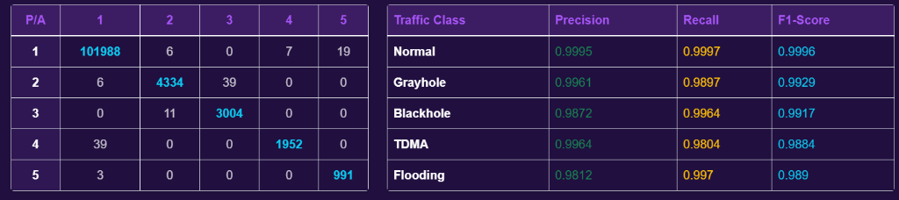

Fig. 1 Algorithm Performance Analysis
Figure 3 shows the algorithm performance analysis interface of the proposed unified ensemble model. The interface presents the unified ensemble model report, these results confirm the effectiveness of the hybrid ensemble learning strategy in classifying and preventing cyberattacks.
Table 2 Comparative Analysis of Base Models and the Proposed Unified Method
Model | Classification Rate | Positive Predictive Value | Detection Rate | Harmonic Score
Unified Ensemble | 99.88 | 0.99 | 0.99 | 0.99
XGBoost | 99.73 | 0.95 | 0.99 | 0.97
Random Forest | 99.71 | 0.93 | 0.99 | 0.96
Multilayer Perceptron | 90.76 | 0.18 | 0.20 | 0.19
Autoencoder | 99.12 | 0.98 | 0.99 | 0.98

Table 2 compares the performance of selected high-performing machine learning models with the proposed unified ensemble model. The results of the comparison suggest that the unified ensemble model is more effective in comparison with base models in achieving better detection and stability of classification. The ensemble method is advantageous as it acts as a way of leveraging the strengths of learning algorithms.
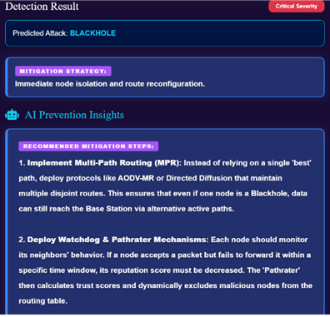
Fig.4 Attack Detection and Prevention
Fig. 4 presents the real-time cyberattack detection output. The system identifies attack type, severity level, and provides mitigation recommendations. This proves the real time detection and prevention of the system.
Fig.5 demonstrates the number of cyberattacks detected by days, and we can realize when attacks were active and when they were not. The line graph has made it easy to determine the best attack times in the time chosen and Fig.6 shows risk chart classifies the nodes into critical, high, medium and low risk based on the severity of attacks detected.
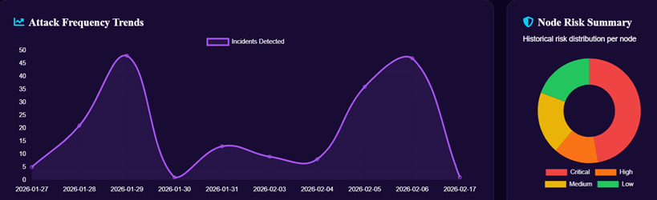
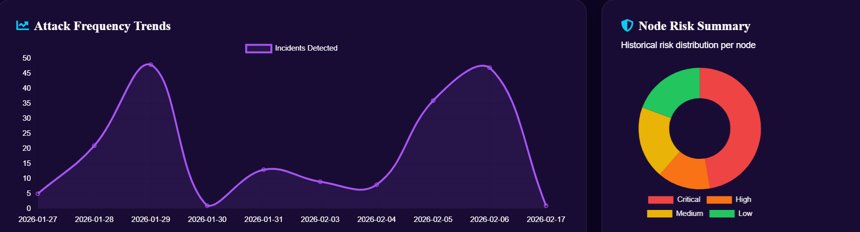
Fig.2 Attack Frequency Trends


Fig.6 Risk Node Summary
The results of the experimental and implementation activity demonstrate that the unified ensemble structure is characterized by a high-detection accuracy, better classification reliability, detection in real-time, and forensic quality security analysis that allow applying the application to real-life circumstances of a Wireless Sensor Network.

CONCLUSION
In the case of Wireless Sensor Networks, the suggested framework gives an integrated ensemble-based system of cyberattacks detection and classification. The system integrates several different learning models into a single ensemble model including Random Forest (RF), XGBoost, Multilayer Perceptron (MLP), and Autoencoder to improve the detection accuracy, classification stability, and the abilities to detect anomalies. This combined ensemble model has a high detection rate of 99.88 and is effective to classify various types of cyberattacks. Also, the model facilitates real-time monitoring of cyberattacks, forensic logging and generation of prevention recommendations. These properties make the system more useful in practice in Wireless Sensor Network and Internet of things based security systems. In general, the suggested framework will fully support the sophisticated security monitoring of the next-generation WSN and IoT network systems and suggest a smart framework to identify and classify the cyberattacks in the context of wireless sensor networks.

FUTURE WORK
Future studies will be aimed at enhancing the given system by integrating modern deep learning frameworks such as Graph Neural Networks and Transformer based framework in order to increase the precision of cyberattacks detection in a massive scale Wireless Sensor Networks. In addition, forensic logging with the help of a safe blockchain can also be implemented as well, to improve integrity.

REFERENCES
- Dr. B. Karthikeyan, MS. M. Kamali , " Detection of Attacks in Wireless Sensor Networks Using Machine Learning Algorithms " , International Journal of Research Publication and Reviews, Vol 6, no 2, pp 3454-3460 February 2025
- Al-Quayed, Z. Ahmad, and M. Humayun, "A Situation Based Predictive Approach for Cybersecurity Intrusion Detection and Prevention Using Machine Learning and Deep Learning Algorithms in Wireless Sensor Networks of Industry 4.0," IEEE Access, vol. 12, pp. 34800-34816, 2024, presented at the IEEE Access Conference, New York, USA, March 2024, doi: 10.1109/ACCESS.2024.3372187
- M. Anwer, S. M. Khan, M. U. Farooq, and . Waseemullah, “Attack Detection in IoT using Machine Learning”, Eng. Technol. Appl. Sci. Res., vol. 11, no. 3, pp. 7273–7278, Jun. 2021
- Delwar, Tahesin Samira, Unal Aras, Sayak Mukhopadhyay, Akshay Kumar, Ujwala Kshirsagar, Yangwon Lee, Mangal Singh, and Jee-Youl Ryu. 2024. "The Intersection of Machine Learning and Wireless Sensor Network Security for Cyber-Attack Detection: A Detailed Analysis" Sensors 24, no. 19: 6377. https://doi.org/10.3390/s24196377
- Tamara Zhukabayeva, Atdhe Buja, Melinda Pacolli, Yerik Mardenov, "Detecting network security incidents in wireless sensor networks using machine learning ," Detecting network security incidents in wireless sensor networks using machine learning Indonesian Journal of Electrical Engineering and Computer Science,Vol. 37, No. 3, March 2025, pp. 1650~1660, ISSN: 2502-4752, DOI: 10.11591/ijeecs.v37.i3.pp1650-1660,DOI: http://doi.org/10.11591/ijeecs.v37.i3.pp1650-1660
- Behiry, M.H., Aly, M. Cyberattack detection in wireless sensor networks using a hybrid feature reduction technique with AI and machine learning methods. J Big Data 11, 16 (2024). https://doi.org/10.1186/s40537-023-00870-w
- G. Al Sukkar and S. Al-Sharaeh, “Enhancing Security in Wireless Sensor Networks: A Machine Learning-based DoS Attack Detection”, Eng. Technol. Appl. Sci. Res., vol. 15, no. 1, pp. 19712–19719, Feb. 2025.
- Khan, I., Junaid Khan, Bangash, S. H., Waqas Ahmad, Khan, A. I., & hameed , khalid. (2024). Intrusion Detection Using Machine Learning and Deep Learning Models on Cyber Security Attacks. VFAST Transactions on Software Engineering, 12(2),95–113. https://doi.org/10.21015/vtse.v12i2.1817.
- Sadia, H., “Intrusion Detection System for Wireless Sensor Networks: A Machine Learning Based Approach”, IEEE Access, vol. 12, IEEE, pp.52565–52582,2024. doi:10.1109/ACCESS.2024.3380014
- Buja, Atdhe & Zhukabayeva, Tamara & Pacolli, Melinda & Mardenov, Yerik. (2025). Detecting network security incidents in wireless sensor networks using machine learning. Indonesian Journal of Electrical Engineering and Computer Science.37.1650-1660. 10.11591/ijeecs.v37.i3.pp1650-1660.
- Salmi, S., Oughdir, L. Performance evaluation of deep learning techniques for DoS attacks detection in wireless sensor network. J Big Data 10,17(2023). https://doi.org/10.1186/s40537-023-00692-w
- N.Harini, D. Siva Naga Srivalli, A. Asritha, A.Govardhini, G.Pujitha, and B.Geetha Bhavani, “CyberSecurity Intrusion Detection in Industry 4.0 WSN’s Using ML/DL”, Int. J. Comput. Eng. Res. Trends, vol. 12, no. 2, pp. 18–28, Feb. 2025.
- nalluri, suryaprakash, Efficient Intrusion Detection Model for Cyber-Attack Mitigation in Wireless Sensor Networks (December01, 2024).
- Ismail WN. A Novel Metaheuristic-Based Methodology for Attack Detection in Wireless Communication Networks. Mathematics. 2025; 13(11):1736. https://doi.org/10.3390/math13111736
- M. A. Talukder, S. Sharmin, M. A. Uddin, M. M. Islam, and S. Aryal, “MLSTL-WSN: Machine learning-based intrusion detection using SMOTETomek in WSNs,” arXiv preprint arXiv:2402.13277, 2024. [Online]. Available: https://arxiv.org/abs/2402.13277
- Tabbaa, H., Ifzarne, S., and Hafidi, I., “An Online Ensemble Learning Model for Detecting Attacks in WirelessSensorNetworks”,arXive-prints,Art.no.arXiv:2204.13814,2022. doi:10.48550/arXiv.2204.13814.njxaJXAx.
- Alamin Talukder, M., Sharmin, S., Ashraf Uddin, M., Manowarul Islam, M., and Aryal, S., “MLSTL-WSN: Machine Learning-based Intrusion Detection using SMOTETomek in WSNs”, arXiv e-prints, Art. no. arXiv:2402.13277,2024. doi:10.48550/arXiv.2402.13277.
- Sinha, P., Sahu, D., Prakash, S. et al. An efficient data driven framework for intrusion detection in wireless sensor networks using deep learning. Sci Rep 15, 34046 (2025). https://doi.org/10.1038/s41598-025-12867-x
- Shakya, Vandana & Choudhary, Jaytrilok & Singh, Dhirendra. (2025). Deep Learning based Intrusion Detection System for WSN. Procedia Computer Science. 258. 2101-2106. 10.1016/j.procs.2025.04.460.
- Gueriani, Afrah & Kheddar, Hamza & MAZARI, Ahmed Cherif. (2024). Deep Reinforcement Learning for Intrusion Detection in IoT: A Survey. 10.48550/arXiv.2405.20038.
- Gurajada, Lalitha & Rajaputra, Sai & Gogineni, Indira & Shaik, Riaz. (2018). Security Attacks in Wireless Sensor Networks. International Journal of Engineering and Technology(UAE). 7. 322-326. 10.14419/ijet.v7i2.32.15704.
- Gebremariam, G. G., Panda, J., & Indu, S. (2023). Design of advanced intrusion detection systems based on hybrid machine learning techniques in hierarchically wireless sensor networks. ConnectionScience, 35(1). https://doi.org/10.1080/09540091.2023.2246703
- Haque, Ahshanul & Chowdhury, Naseef & Soliman, Hamdy & Hossen, Mohammad Sahinur & Fatima, Tanjim & Ahmed, Imtiaz. (2023). Wireless Sensor Networks anomaly detection using Machine Learning: A Survey. 10.48550/arXiv.2303.08823.
- Ismail, S.; El Mrabet, Z.; Reza, H. An Ensemble-Based Machine Learning Approach for Cyber-Attacks Detection in Wireless Sensor Networks. Appl. Sci. 2023, 13, 30. https://doi.org/10.3390/app13010030

